EDUCATION OBSTACLES, TIPS AND REWARDS!!
Elaine Friedman, corvidconnection@aol.com
Corvid Connection, Clayton, California
Please feel free to contact me via email with questions regarding my lecture or handout. This handout is only a small part of the presentation. Attend the lecture for the complete package!!!!!
As wildlife rehabilitators, we have access to animals that intrigue and entice the public. Programs can vary from introducing wildlife and environmental concepts to the public to actual hands on activities demonstrating to kids what a rehabilitator’s day might involve. Your job as an educator is to intrigue, instruct, and involve your students.
There is a developing pitfall that you will encounter if you haven’t already done so. School districts are requiring contracts, liability insurance, and fingerprinting with background checks if you intend to do a presentation on school grounds. The schools require an endorsement on your actual insurance policy. Have the teacher check the needs or do this on your own long before the program is scheduled. Otherwise you will be jumping through multiple time consuming hoops at the last minute.
Tool #1-You You are a professional. You have knowledge and skills that the general public doesn’t have. You might be nervous about getting up in front of a group of people, but there are solutions to that anxiety. If you look and act like you are in charge, the audience will give you their attention and respect. If you are nervous about public speaking, experiment with what works to help you remain calm in front of an audience. Know where the clock is to manage your time. Have a drink within reach that will ease any urge to cough. My favorite is slightly carbonated juice. Use power point, slides, a chalk board, or even a poster containing an outline to keep you on track. Bring a series of props to begin or supplement a subject. These can be your crutch to stay on track. Realize that a member of the audience who seems to know it all on a particular subject usually has only internet or book knowledge while your knowledge is hands on. Try giving the “know it all” a question that requires in depth knowledge that you have. Take the time to plan ahead to give yourself an air of confidence. Make sure that you are familiar and comfortable with your subject. If you are using live animals, work with each animal to be handled prior to doing programming. Don’t try to teach on an empty stomach. Survey the room prior to getting in front of the audience. Read your audience from the minute you see them. Look into their eyes and faces. Let them know your rules and follow through on these rules! Ask a couple of questions to test their level of knowledge. Be ready to adjust your program up or down, faster or slower and less complicated depending on the responsiveness of the audience. Don’t be hesitant about cutting or adding material. You should always have more props or information than you feel you need for the program. It is always a perk to be able to “pull a rabbit out of a hat” and have something special for a great question or especially interested group.
This is important for control of the group! Check with the teacher or students at the beginning of the program what technique or hand sign they use to quiet down. Then use this tool in your own interactions with the group.
Tool#2-What are you going to wear? Will you look like a leader or just a member of the group? A comfortable but professional look leads to a more attentive audience. I use a website called corporatecasuals.com to embroider my logo on reasonably priced shirts and jackets.
Tool # 3-A bright and spacious room filled with attention getters is a great supplement to any program. A drab room which is what you will find if given an empty classroom on campus can be quickly filled with intriguing props that you transport consolidated in plastic storage boxes. A single carload can visually fill a room.
Tool # 4-Preserved specimens that you can collect and prepare. We only use animals that have died or inanimate objects and we explain to the kids that nothing was killed to make these specimens. You can request the right to salvage migratory birds and related items to be listed on your federal education permit. Our mounts were prepared by a volunteer trained in taxidermy at a local wildlife center. The plastic viewing boxes that we use for specimens are low in cost and can be purchased at containerstore.com. Check with your state for salvage permit requirements. In California, there is a separate scientific collection permit which includes salvage. Also, don’t forget to have those ragged looking touchables. Students highly value the opportunity to investigate and learn through the use of multiple senses like touch. Skulls and other bones can be salvaged from the environment or purchased. My source is boneroom.com. Realize that even a simple item like an oak branch embedded with acorns as the result of the work of acorn woodpeckers inspires wonder.

Tool #5-Your photographs! Seal your 8x10 photos in self laminating pouches so they can be used over and over again. Find the pouches on Amazon.com. I prefer Scotch Self-Sealing Laminating Pouches. I almost always have a camera with me and supplement most of my programs with wildlife photos and stories involving the photos,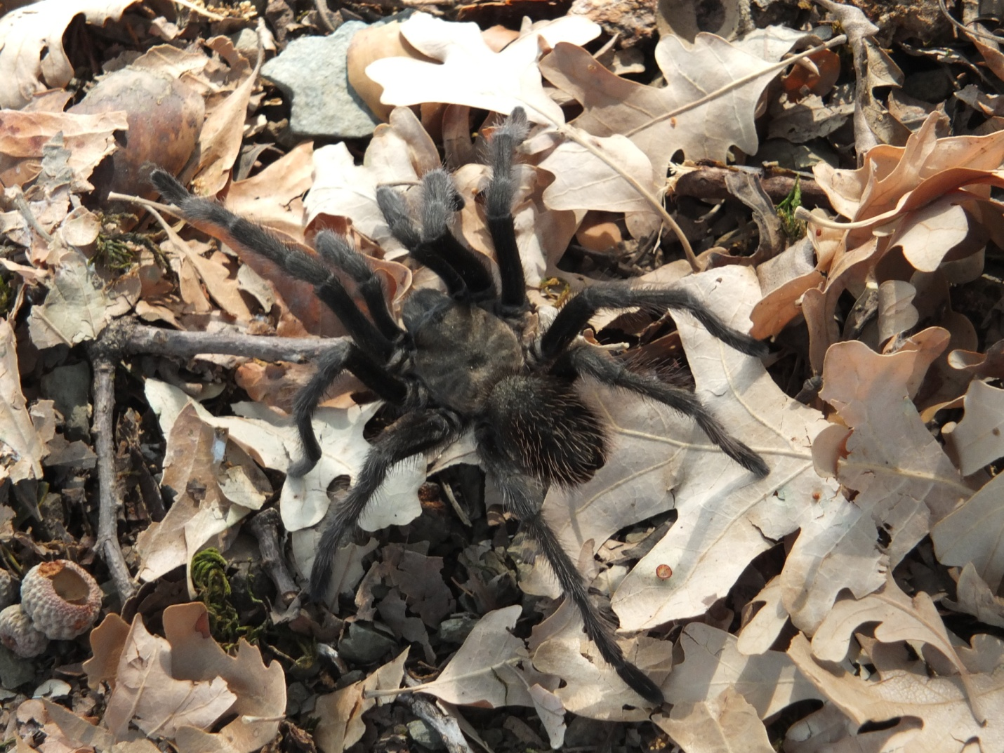
Show a sequence of laminated photos. Kids are wide eyed seeing for example a scenario of a bobcat grabbing and trotting of with a small mammal.
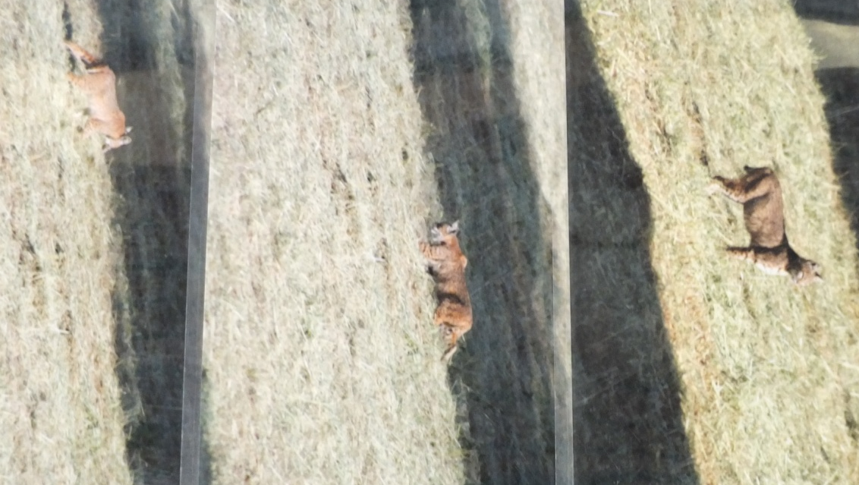
Combine a photo with a stuffed toy animal. Add in the story behind the photo to inspire interest in your topic.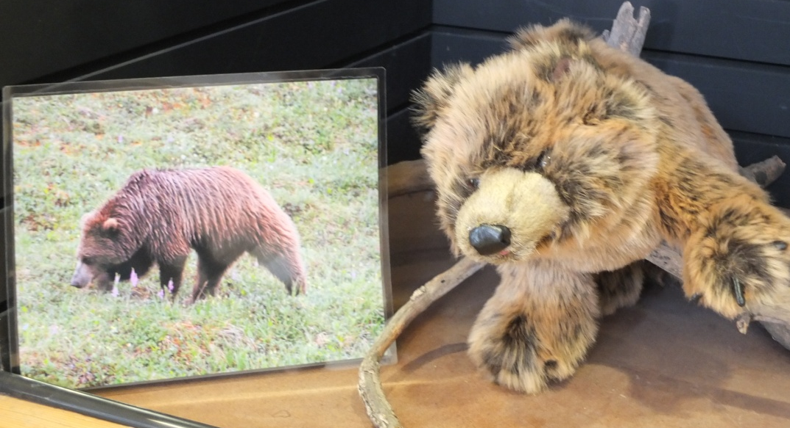
Tool # 6-Be creative in how you present a live animal. Not all animals are comfortable being shown in a traditional way. Work to find a way to feature a permanently injured animal that benefits the animal. We feature birds who are calm in front of an audience but who cannot be handled in falconry equipment using a large, lightweight reptarium. We will also put a table inside a 6x6 see through mesh tent and have a kenneled bird who is a bit of a ham on top of the table. We go in the tent, let the bird step onto the table and have the bird demonstrate some natural behaviors. We also make use of a rescue parrot occasionally to give our migratory birds a break. The parrot is presented on the glove, is housed during the bulk of the program in a good sized cage on wheels and the topic is that this is an example of wildlife in South America. This can open up multiple discussions regarding importation of wild animals from other countries.
Tool #7-Combine a variety of props to deliver a theme. Examples include a table top photo board adorned with 8x10 wildlife related photos, toy stuffed animals, mounts, skulls, skeletons, snake sheds, even a rubber snake.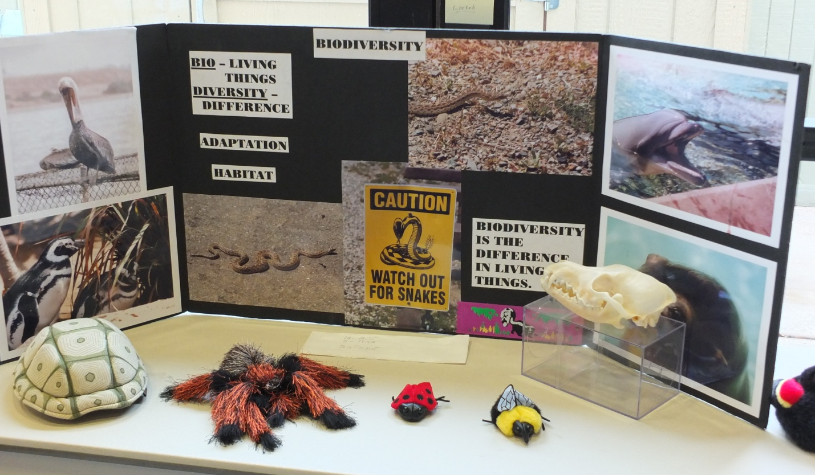
Don’t be afraid to use synthetics like halloween store animals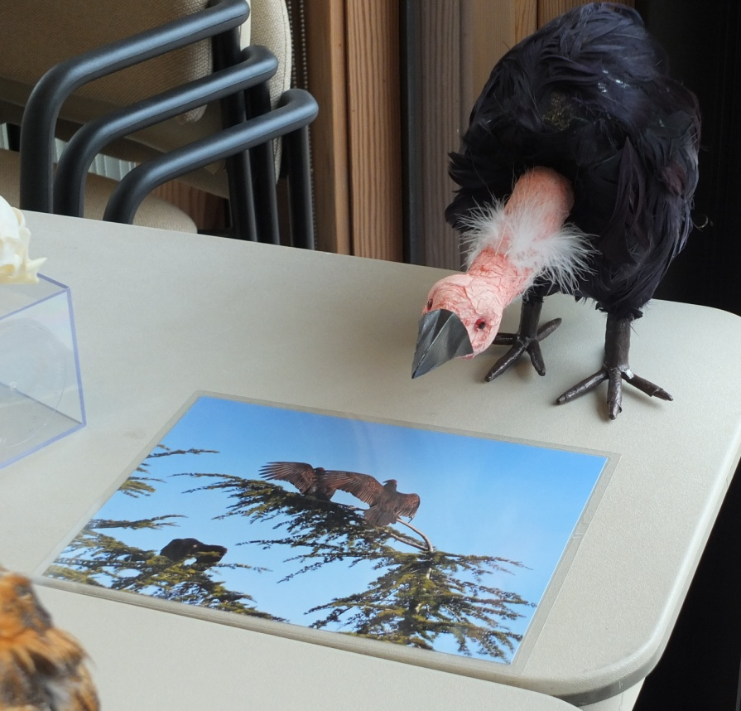
Folkmanis puppets with lifelike features can demonstrate things like webbed feet, a pelican’s beak. 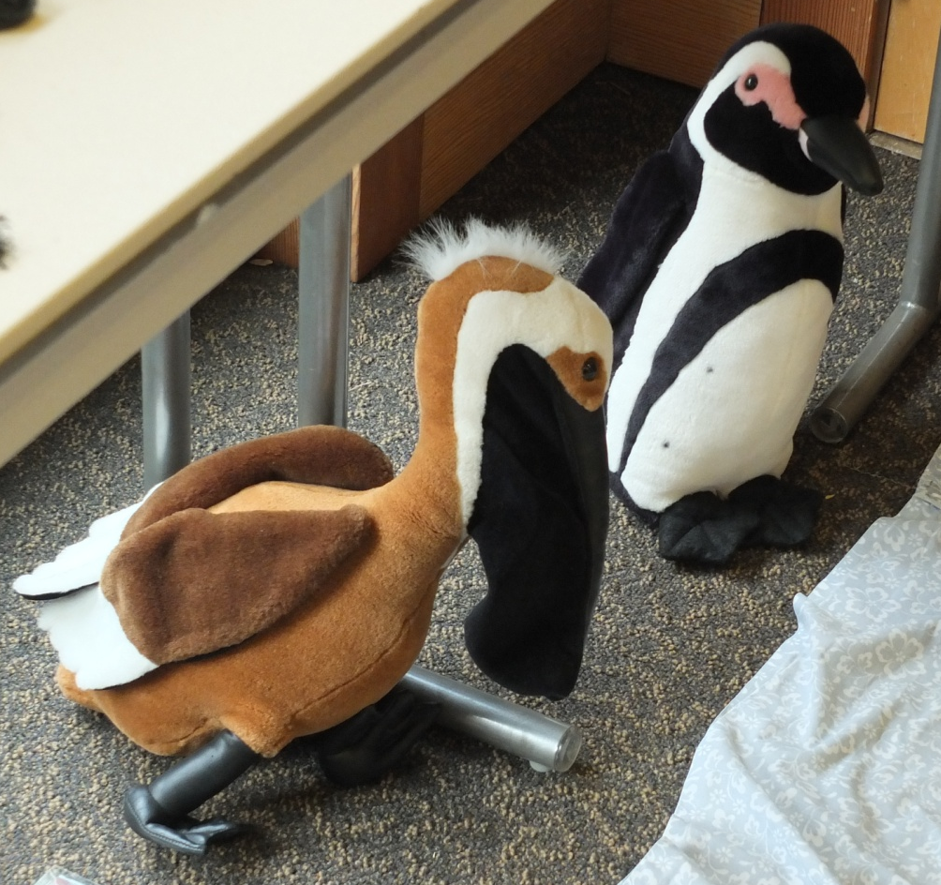
You can create your own charts by using posterboards and felt tip pens. Examples include beaks vs feet, insect mouth parts, food web, parts of a feather.
Make a felt board for a food web that kids can equip, purchase a simple chart or design a chicken or the egg poster.
Borrow from an associate an interesting photo that will augment your programming 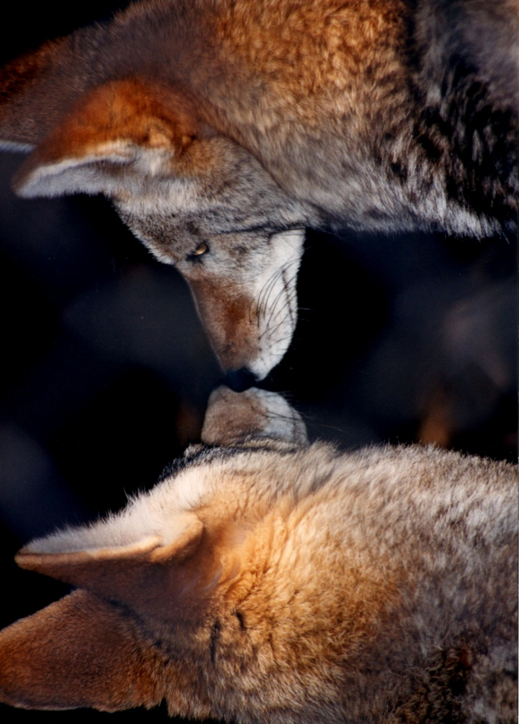
Document in actual photos the behavior of animals in your care.
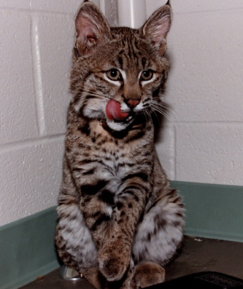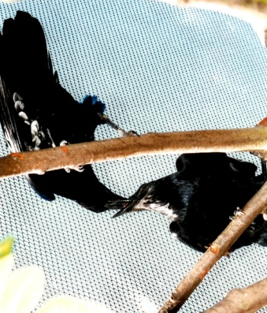
Tool #8-Create a journal that the kids can fill out during and after your programming.
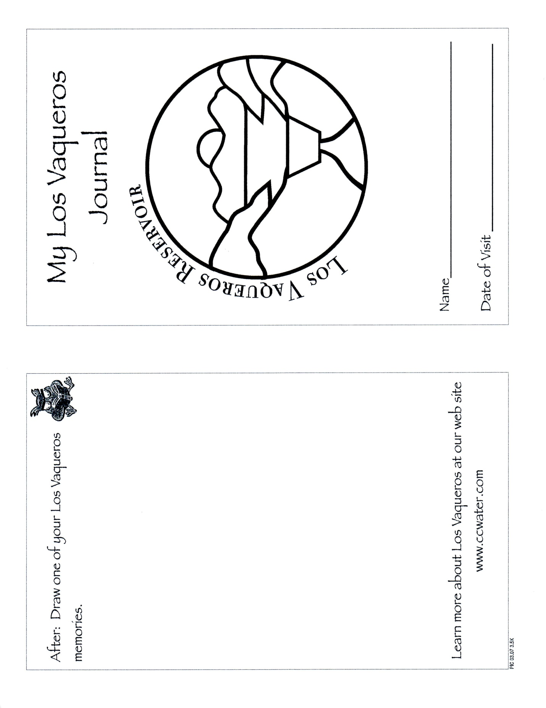
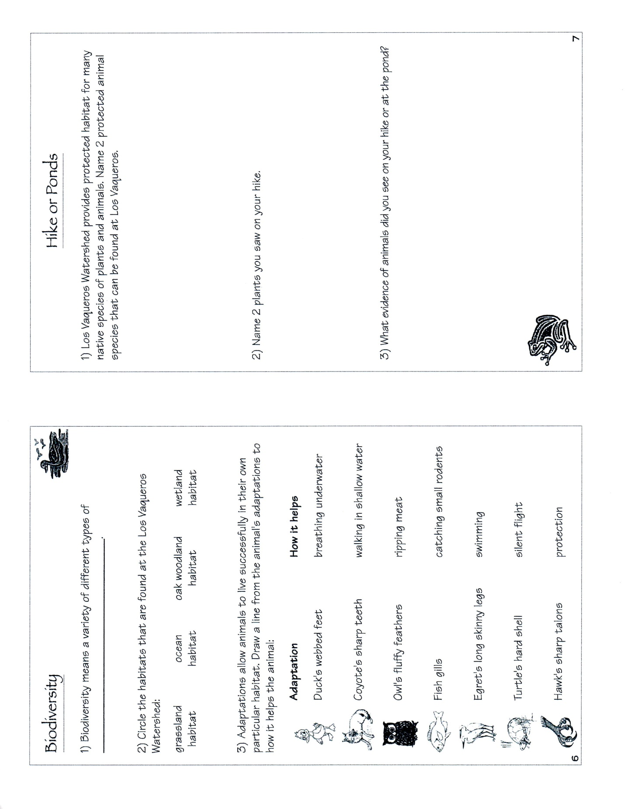

Tool #9-Design an age appropriate workbook to supplement your lesson plan. Have your students visit stations where they will be able to perform interactive learning. 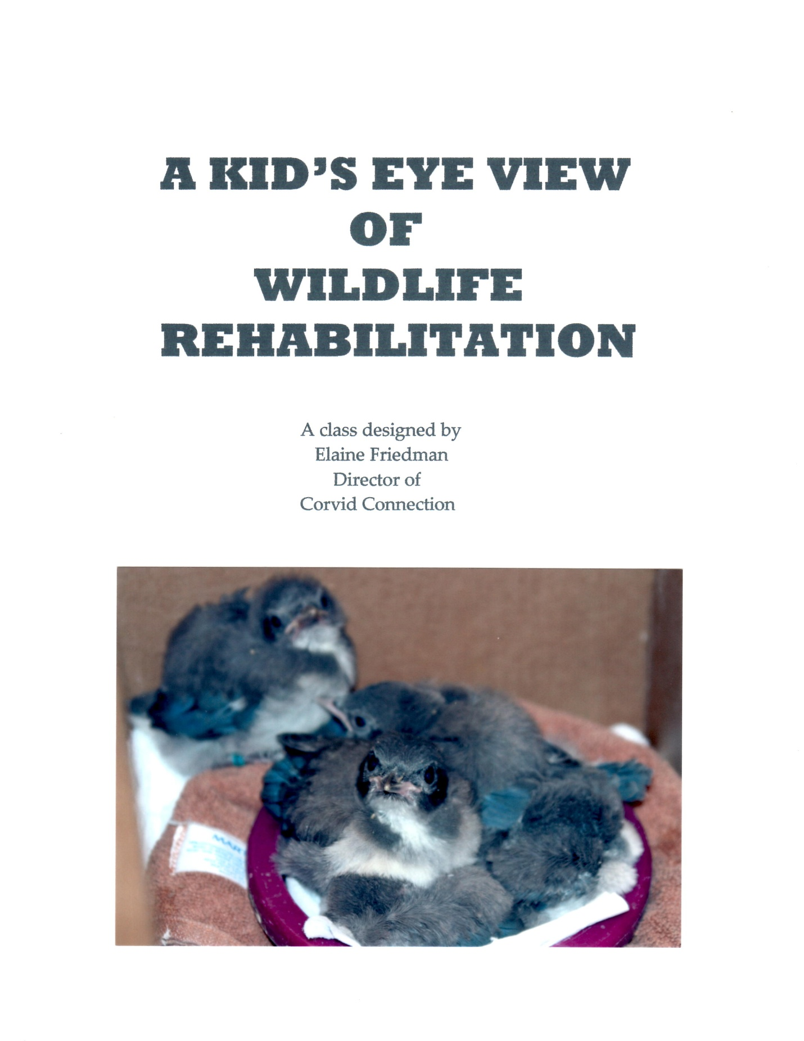
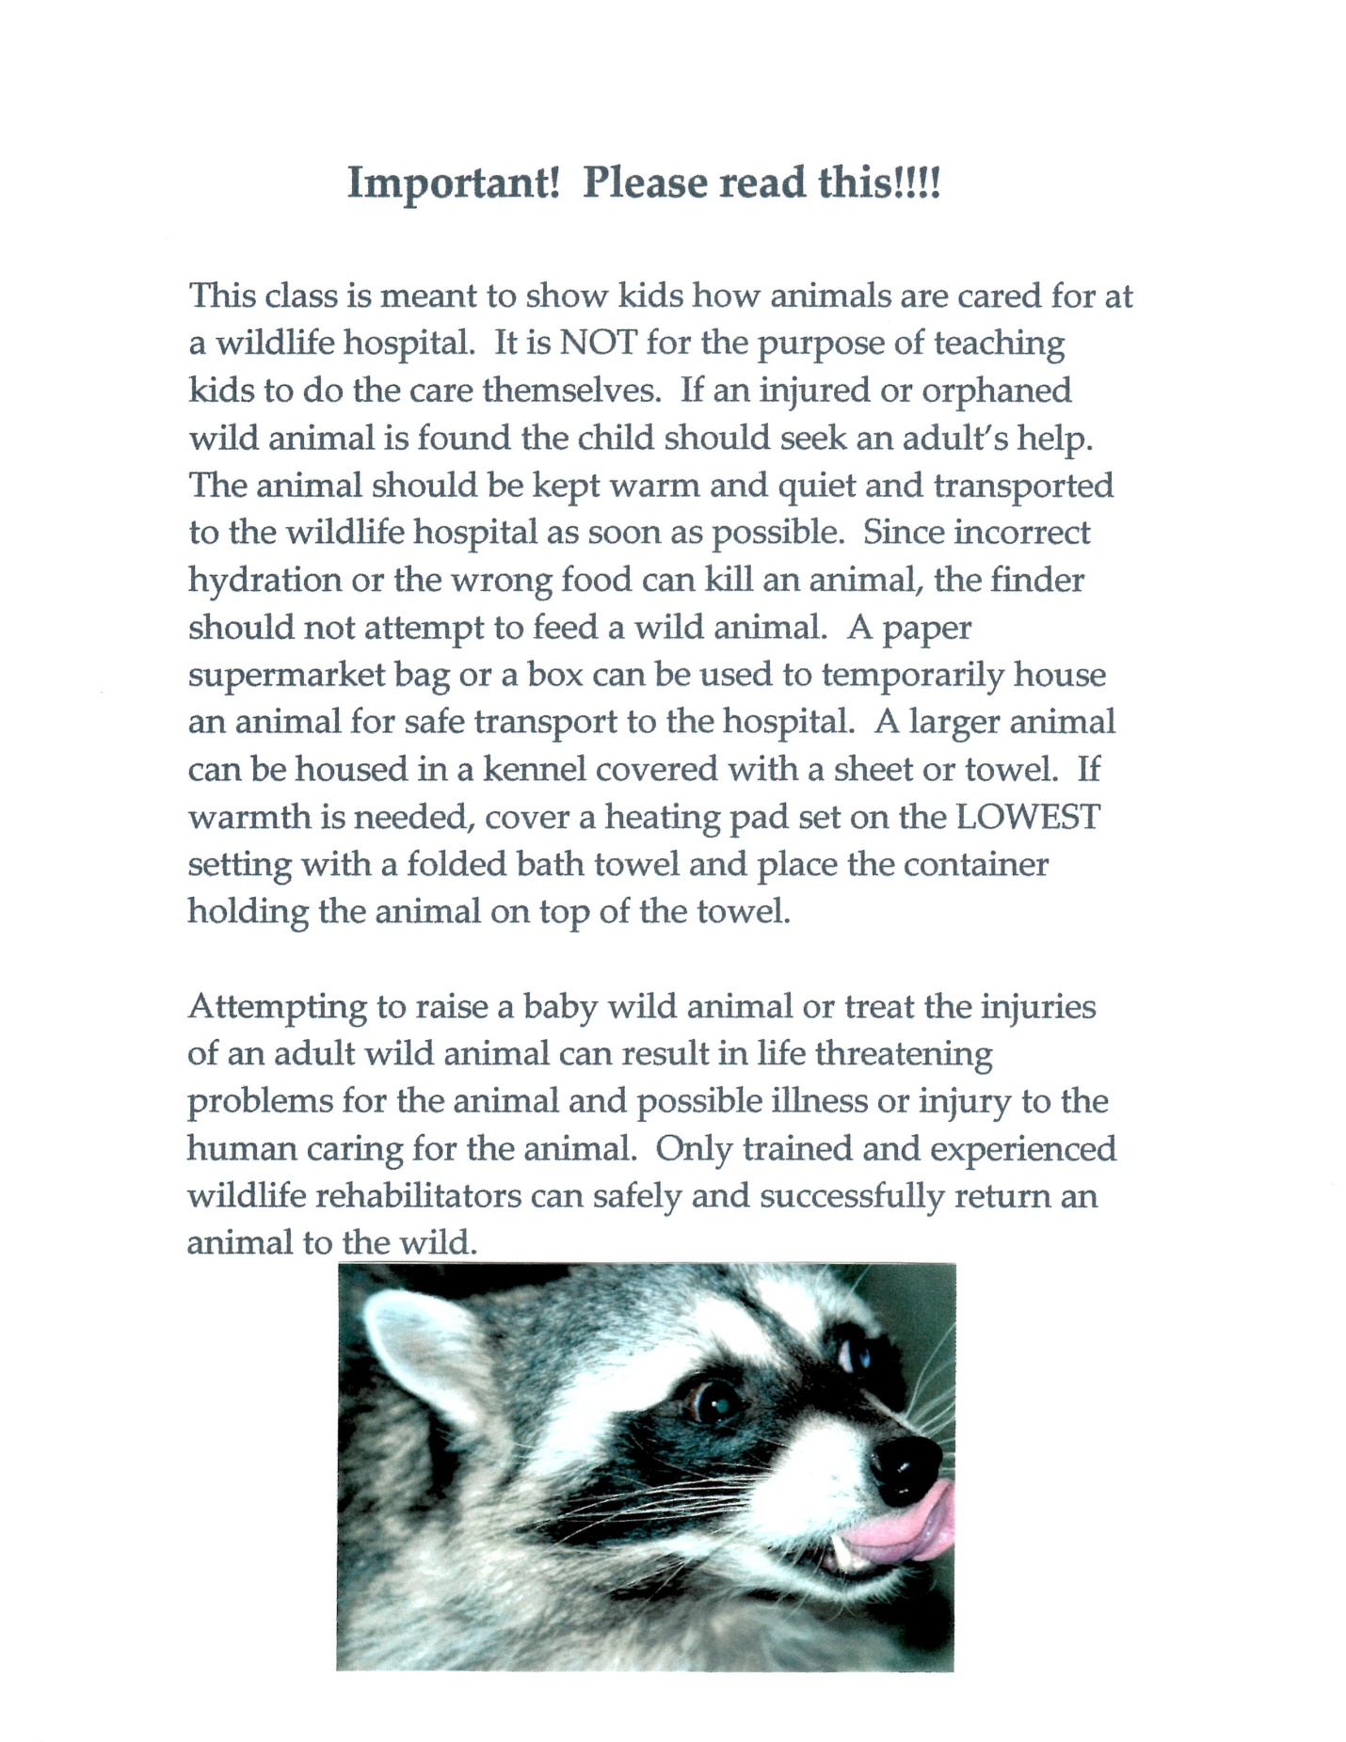

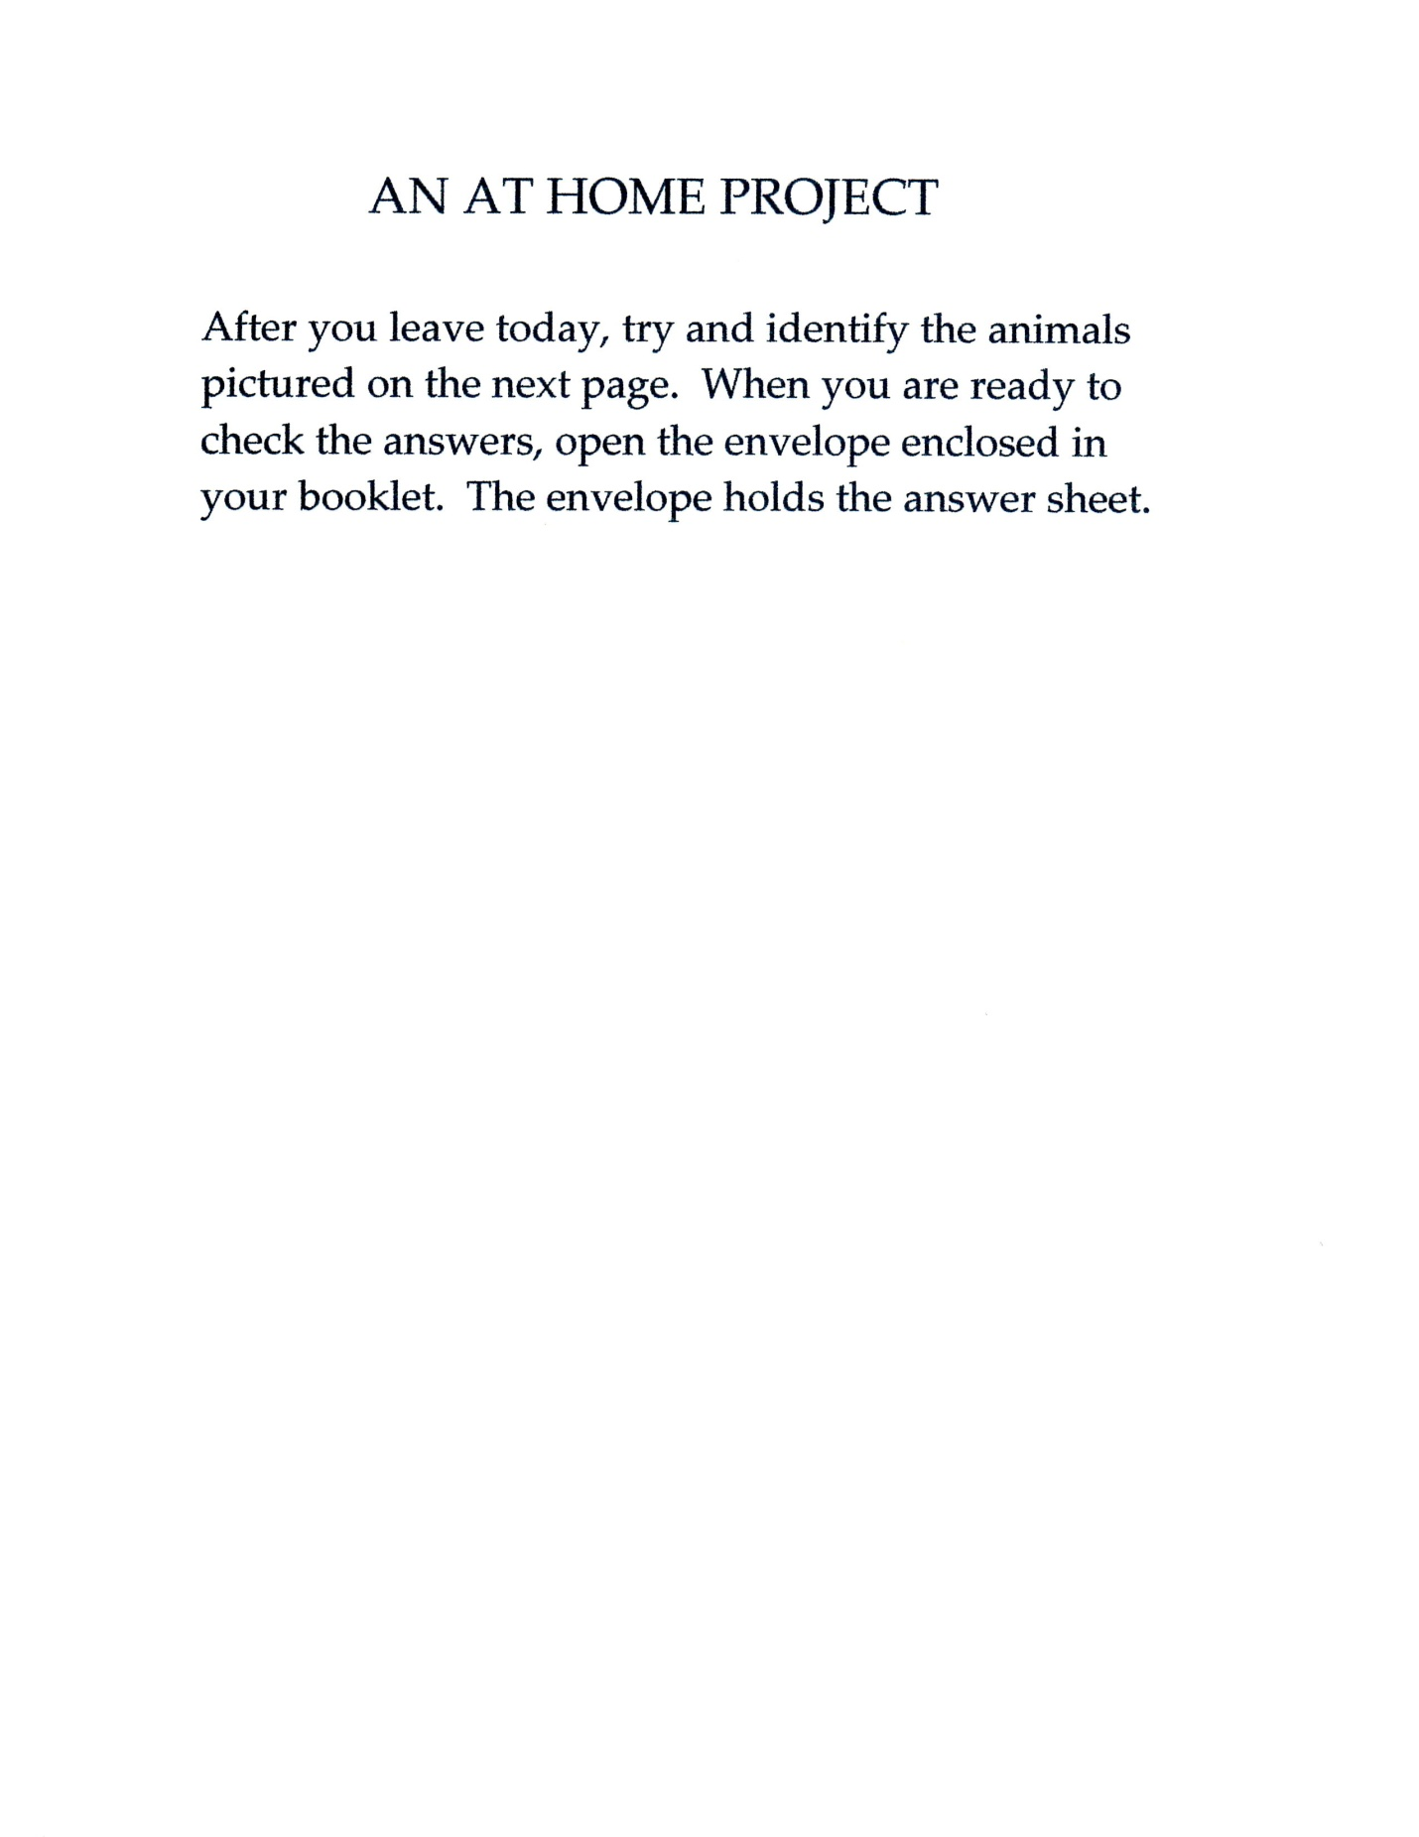

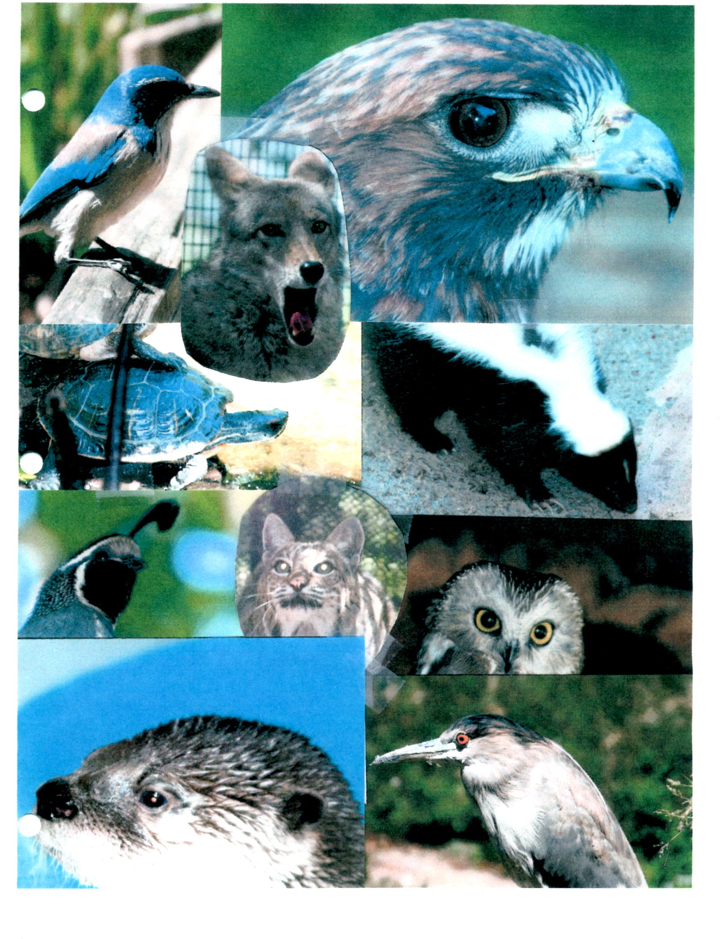

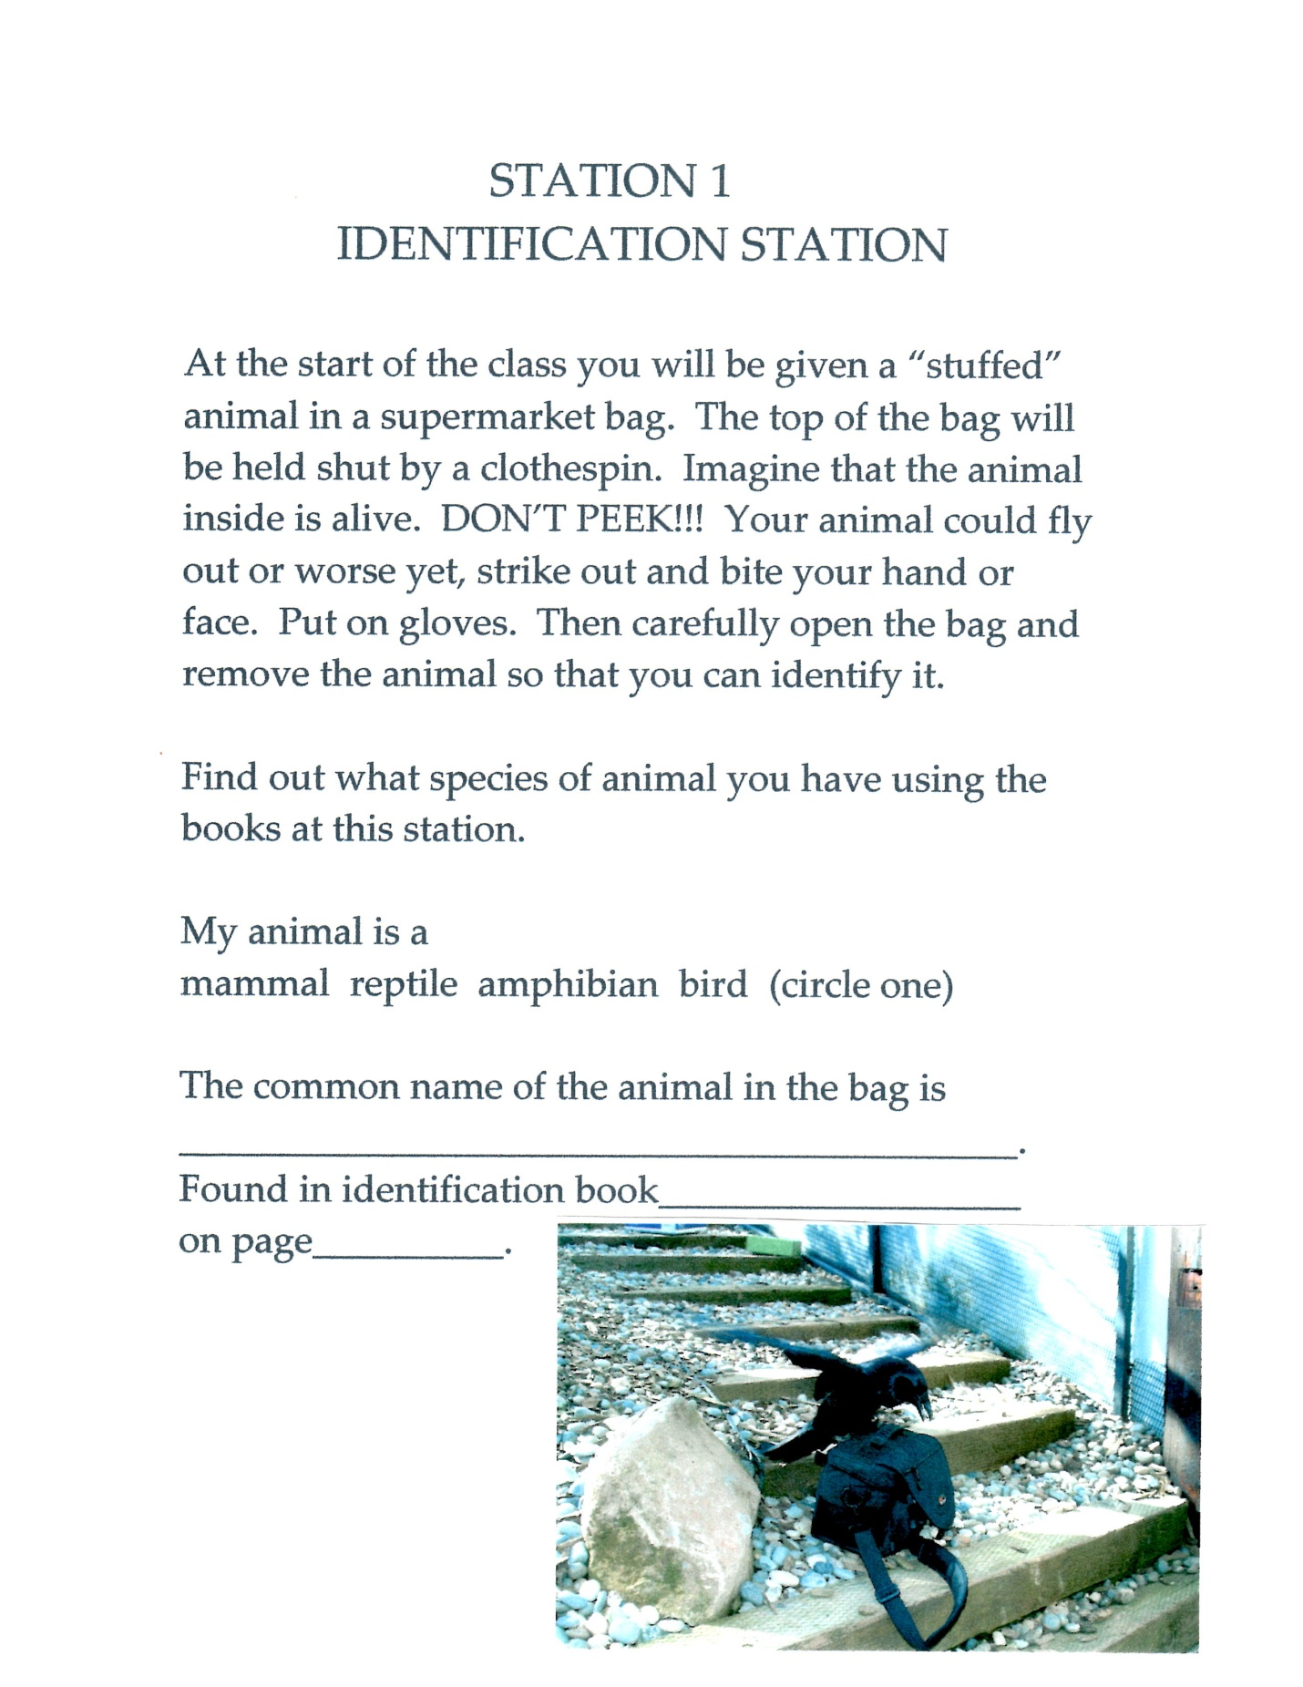

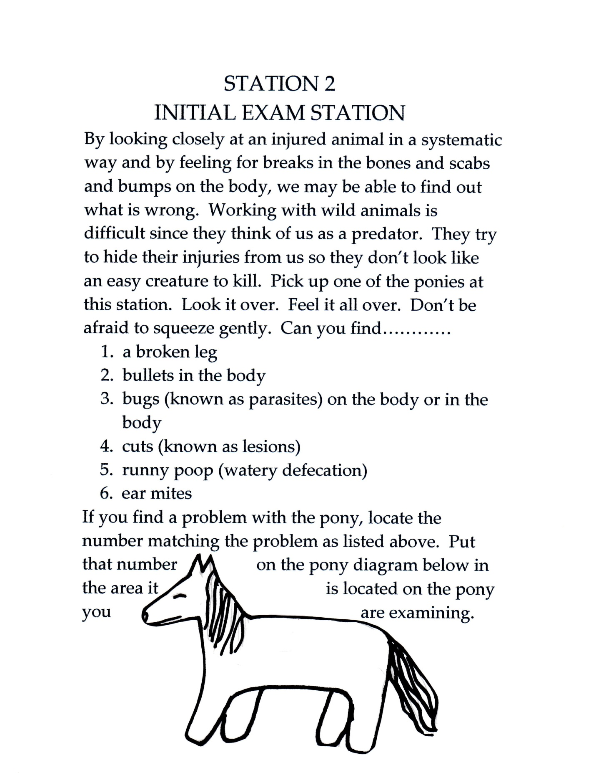

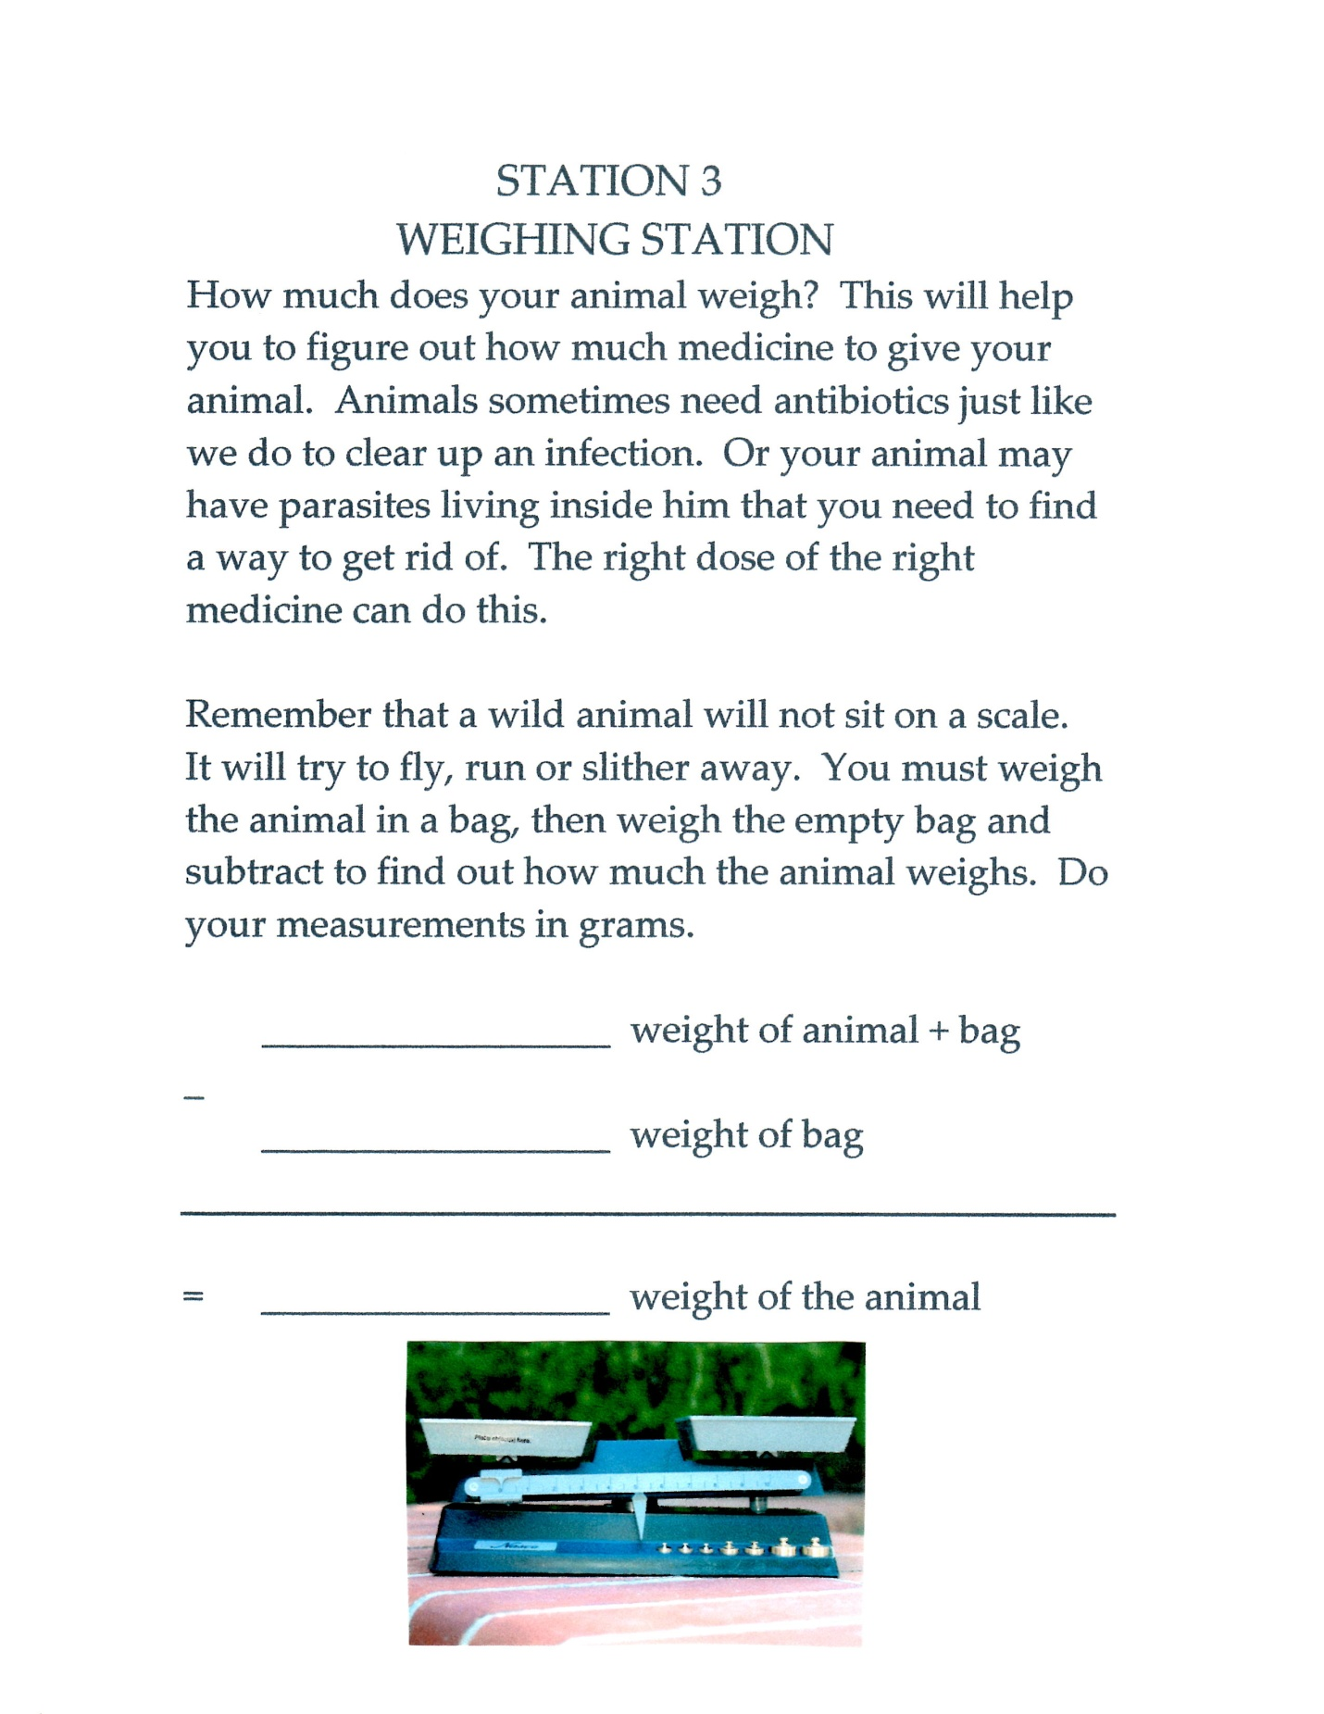

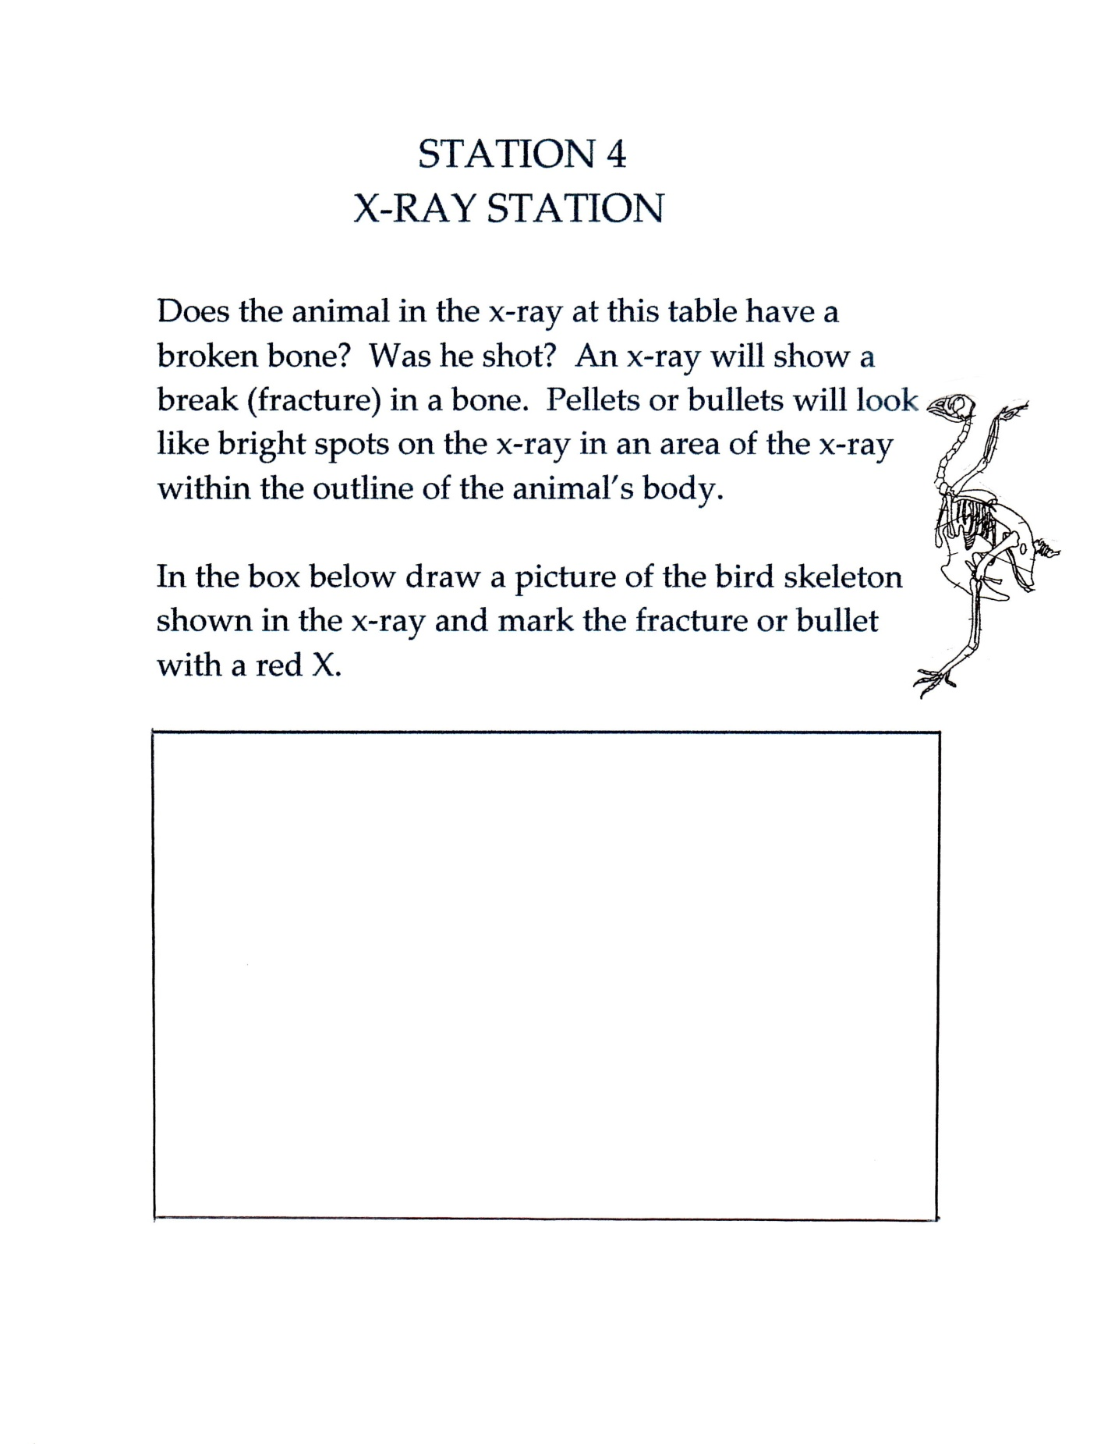

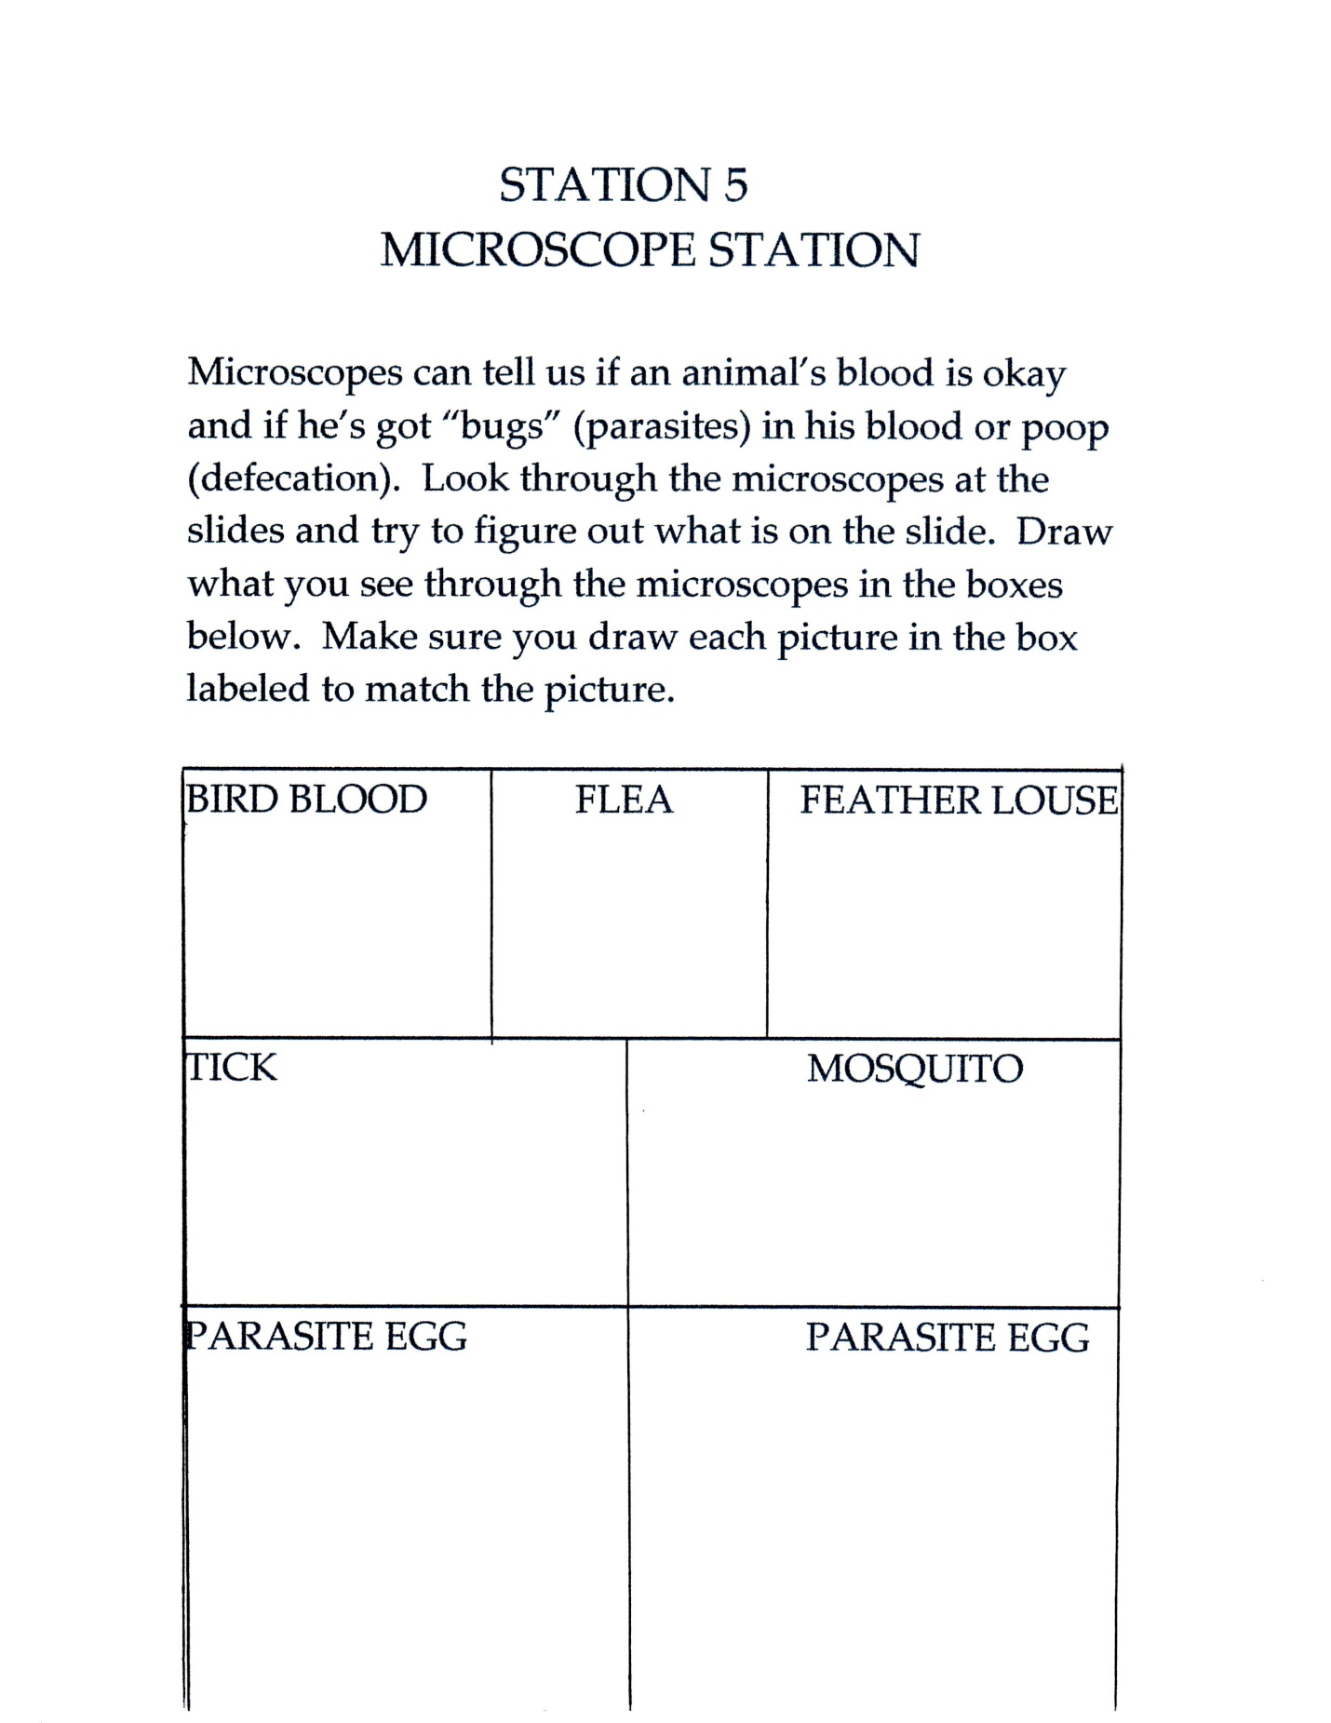

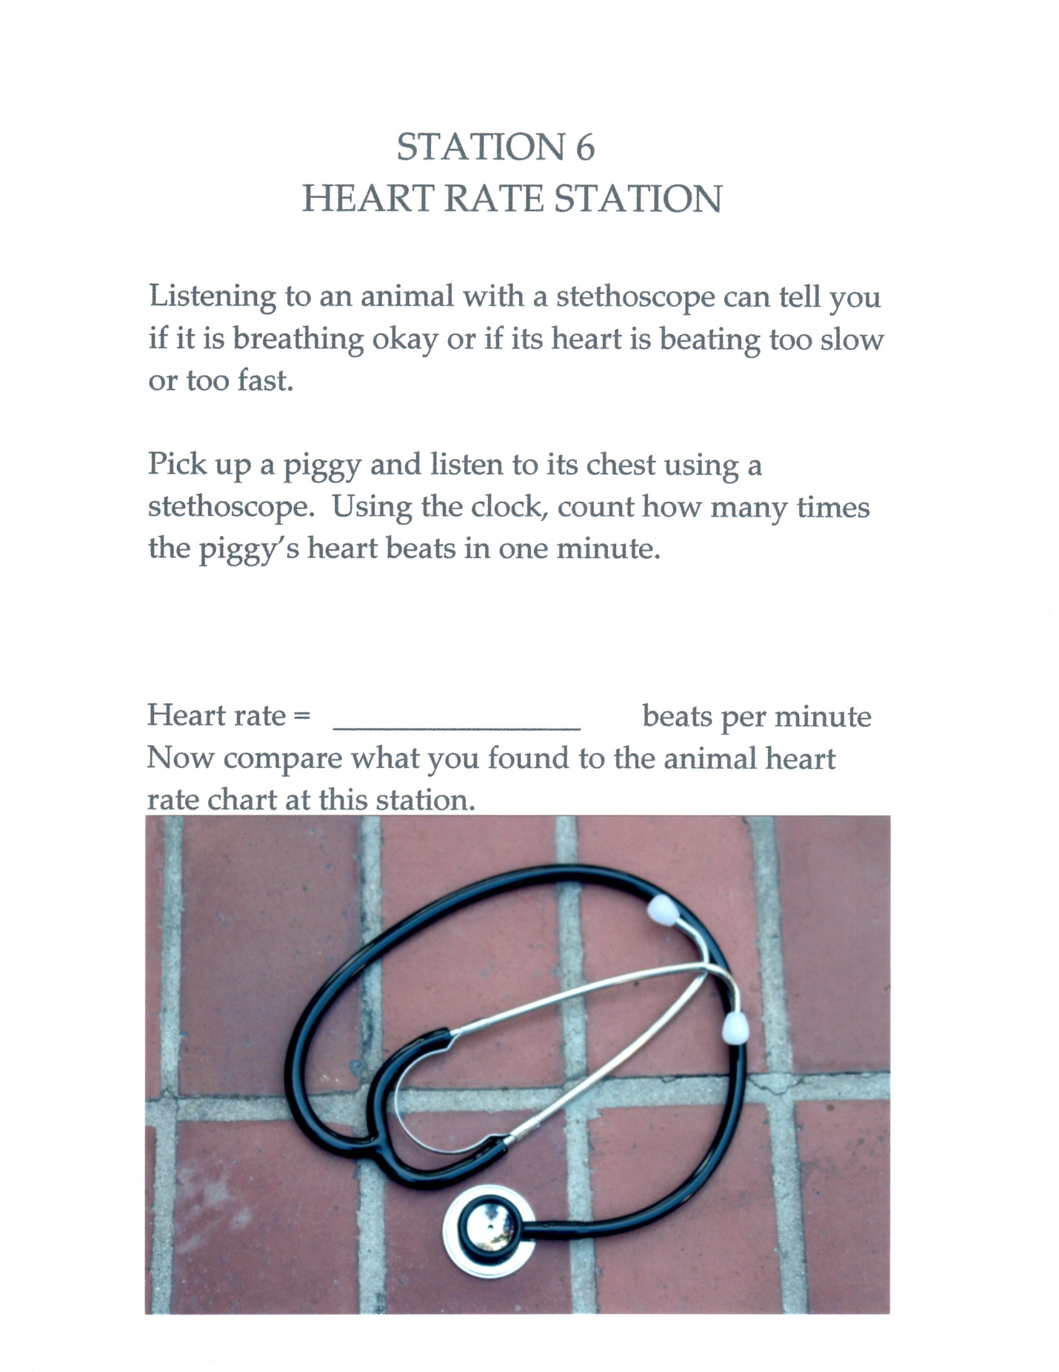

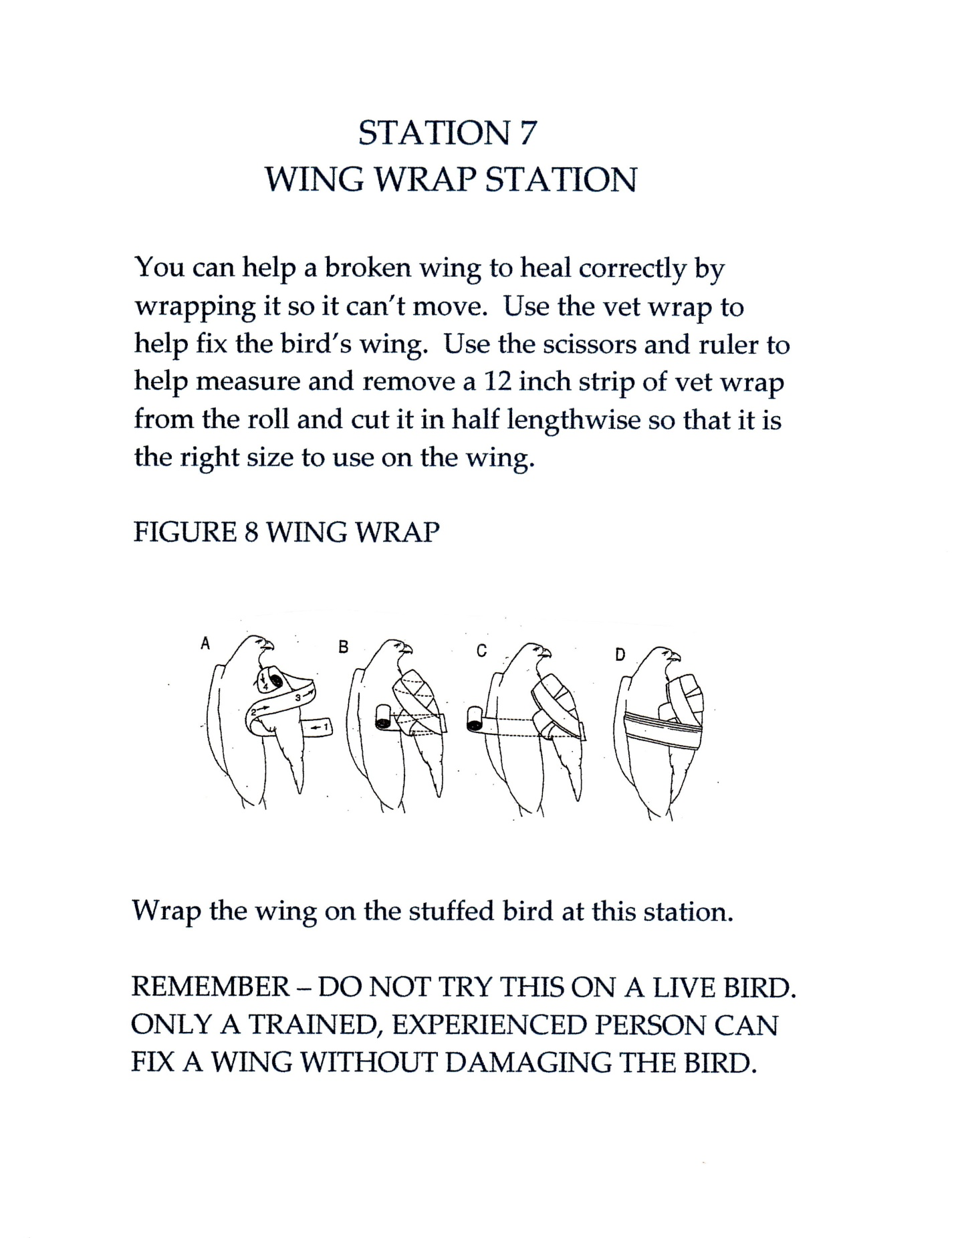

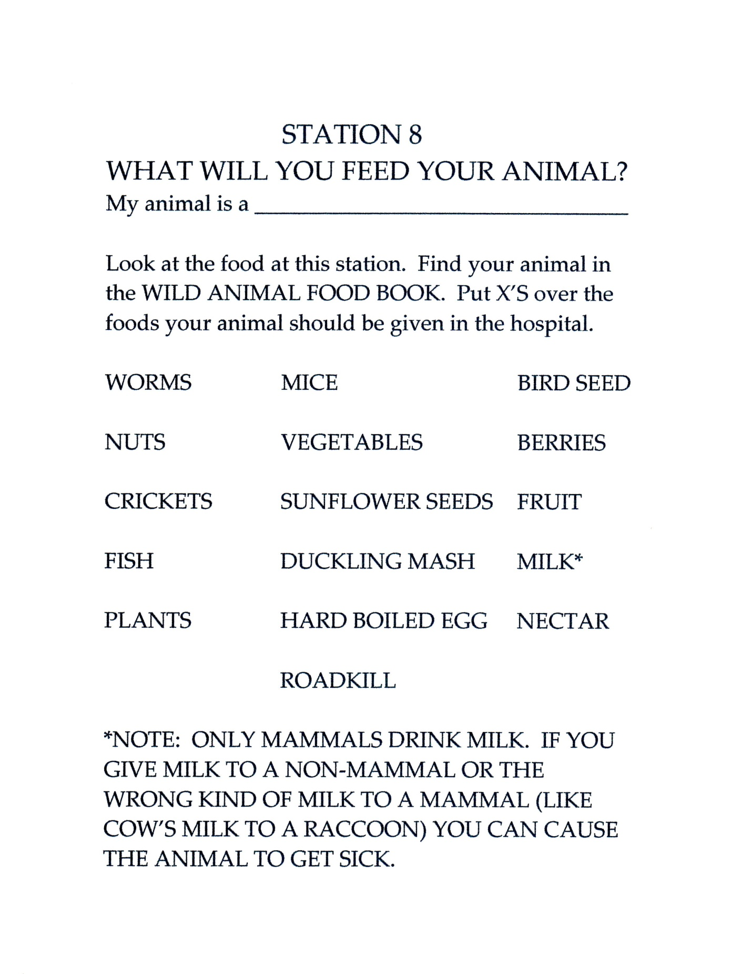

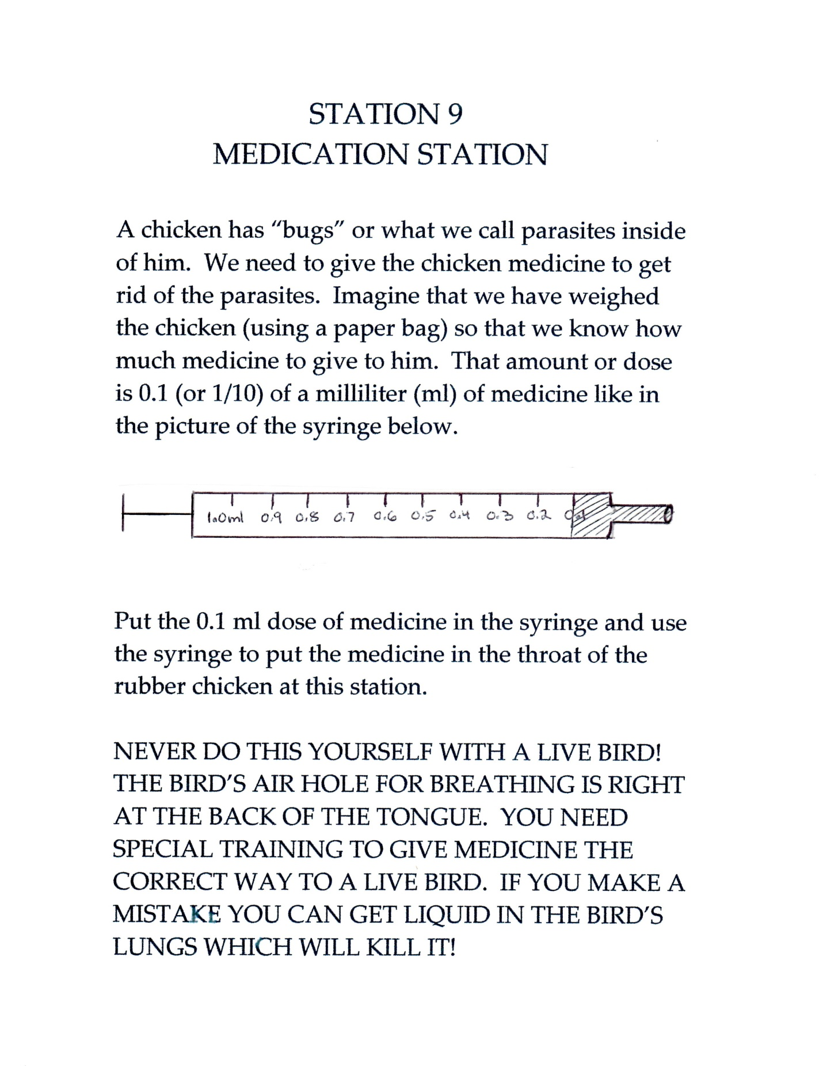

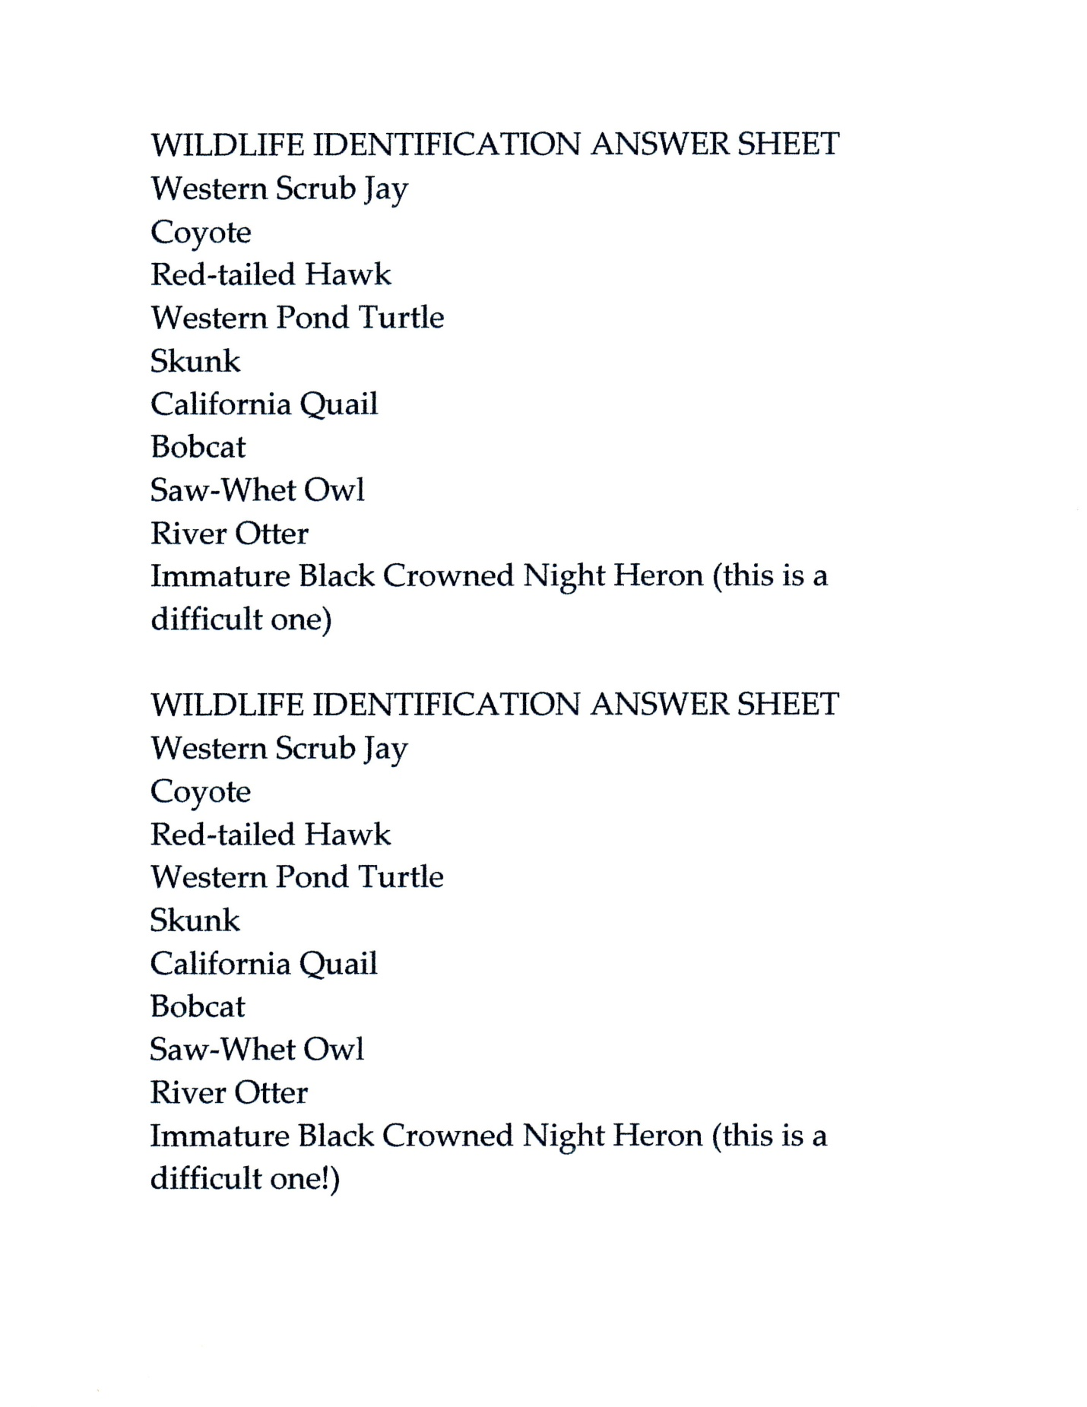
The workbook shown above has been used in scores of programs with rave reviews from both kids and parents. The workshop begins with an hour long introductory class, showing a slideshow of life in a wildlife hospital, introducing permanently injured wildlife and discussing with the group what wildlife rehabilitation involves. We then introduce the concepts of the stations; that this experience is to give the kids an idea of what wildlife rehabilitation involves. We stress that to actually work with animals, hands on training with a mentor and lots of practice in a hospital setting must be done before the skills shown in the workshop can be used. We have gathered a collection of Folkmanis wildlife puppets, and each child is given a different species of animal in a paper supermarket bag closed with a clothespin as they enter the room where the stations are set up. The kids also carry a pencil and the attached workbook. We attempt to break the kids into groups of 3 or 4, pairing multiple skill levels together as best we can. We have had most success with kids ages 8 and older. This program has become popular with homeschool groups in our area, so a typical “class” may consist of up to 30 kids, ages 8 to around 15. The heartbeat station includes toy pigs stuffed with ticking clocks plus heartbeat teddy bears. Our initial exam station has toy ponies spiked with all kinds of physical problems that the kids can see and feel. Xrays were supplied by the local wildlife hospital. The wing wrap station includes many types of toy birds with moveable wings, easy to wrap. The medication station includes a water/food coloring solution. The microscope station has slides both purchased plus those sealed at the wildlife hospital. The microscopes used are very simplistic. The kids get to try out disposable gloves and we make sure we clean stethoscope ear pieces between uses. Every attempt is made to maintain a clean, healthy interactive environment. While the kids are working, experienced adults mingle, assist and answer questions.

